**Neha Maddali**

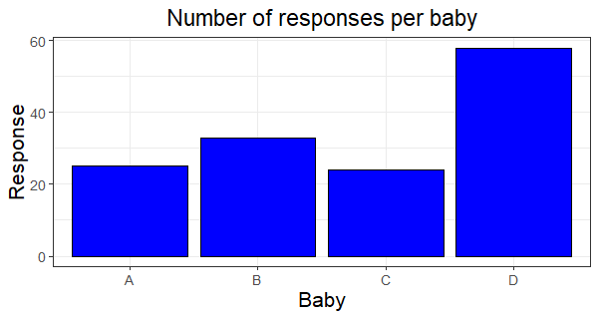The following is a summary table and graph of the data:

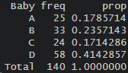

**Do the students/judges detect a resemblance between Dr. Nettleton and any of the babies pictured?**

H0: pA = pB = pC = pD

Ha: at least one pi is different where *i* refers to A, B, C, D

Under the assumption of the null hypothesis, the expected frequency of each baby chosen is 35, with proportion of 0.25.

I am using a Goodness of Fit Test for One Categorical Variable to assess whether the observed distribution of responses differs significantly from the expected distribution, assuming the null hypothesis is true.

Below is the result of the test. The test statistic: X2 = 21.543 with a p-value of 0.0000812

There is enough evidence to suggest that at least one of the proportions pA, pB, pC, pD is different from the others. There is enough evidence to suggest that the students/judges do detect a resemblance between Dr. Nettleton and at least one of the babies pictured.

**Do the students/judges detect a resemblance between Dr. Nettleton and his son Sam?**

H0: the proportion of students/judges detecting a resemblance between Dr. Nettleton and his son Sam (pB) is the same as the proportion for other babies (pA, pC, pD)

p**B =** pothers

Ha: p**B ≠** pothers

pothers = 0.7642857, pB = 0.2357143

I am using a score test since it is a two sample proportions test that assesses the difference in proportions between Dr. Nettleton’s son Sam and the other babies.

Here are the results of the test:

There is significant evidence to suggest that the proportion of students/judges detecting a resemblance between Dr. Nettleton and his son Sam is significantly different from the proportion for other babies. We can conclude that the students/judges do detect a difference in resemblance between Dr. Nettleton and his son Sam compared to the other babies.